# File:COMSATS new logo.jpg - Wikimedia Commons

**OOP Assignment no # 03**

**Submitted to: Sir Shahid Bhatti**

**Submitted by: Talha Manzoor(SP24-BSE-089),AbdulMateen(002),Asad(069)**

**Section: “B”.**

# University Transport System: Java Code Explanation

## Introduction

This document provides an explanation of the Java code for a University Transport System. The system manages the logging of vehicles entering and exiting the university premises, validates user credentials, and generates various reports. The project is implemented using JavaFX for the GUI and file handling for data storage.

## Classes Overview

### 1. LoginPage Class

The LoginPage class serves as the entry point for the application. It displays a login interface and validates user credentials stored in a file named 'Users.txt'. If the credentials are correct, it redirects the user to the Dashboard.

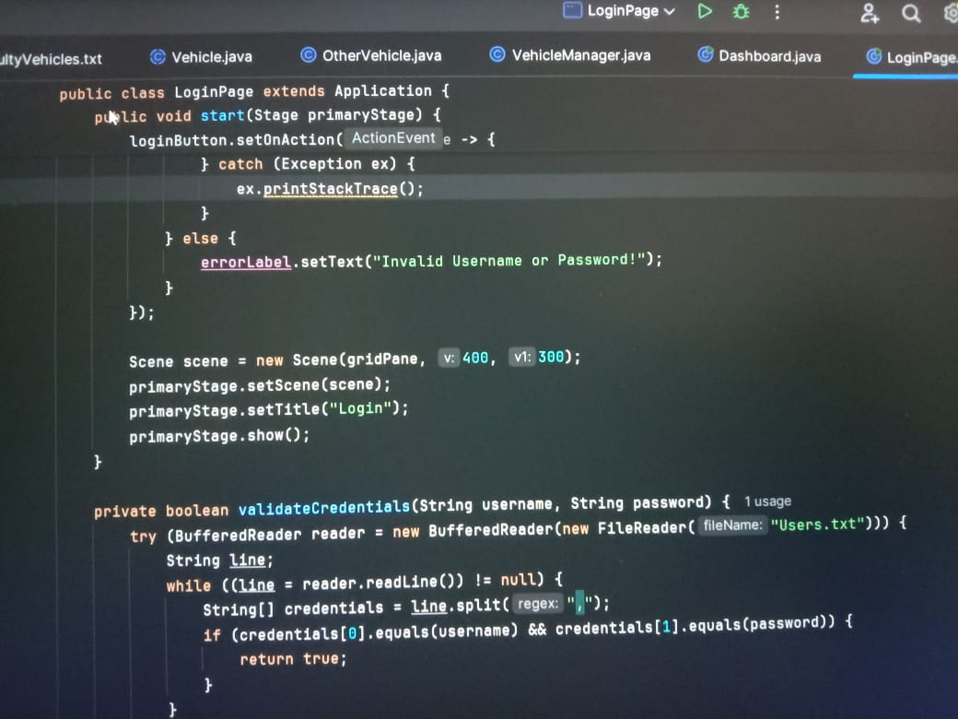

Key Components:

1. GridPane layout for organizing the UI elements.
2. TextField and PasswordField for user input.
3. File handling to validate credentials.

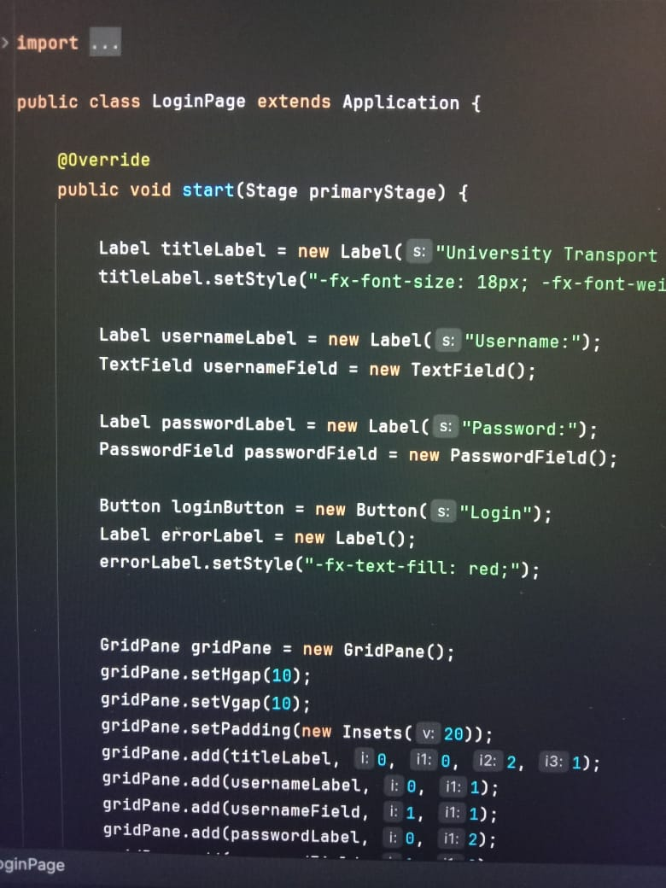

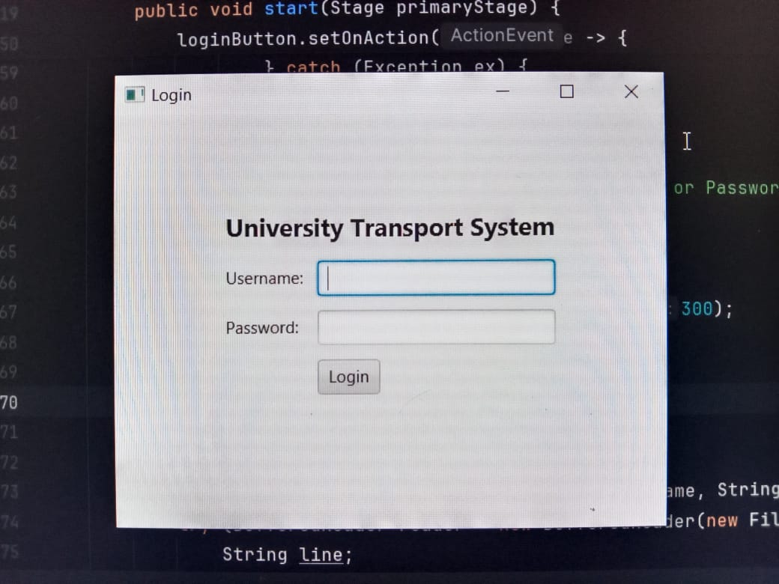

### 2. Vehicle Class

The Vehicle class is an abstract class that serves as a blueprint for different vehicle types. It includes attributes like registration number, entry time, and exit time.

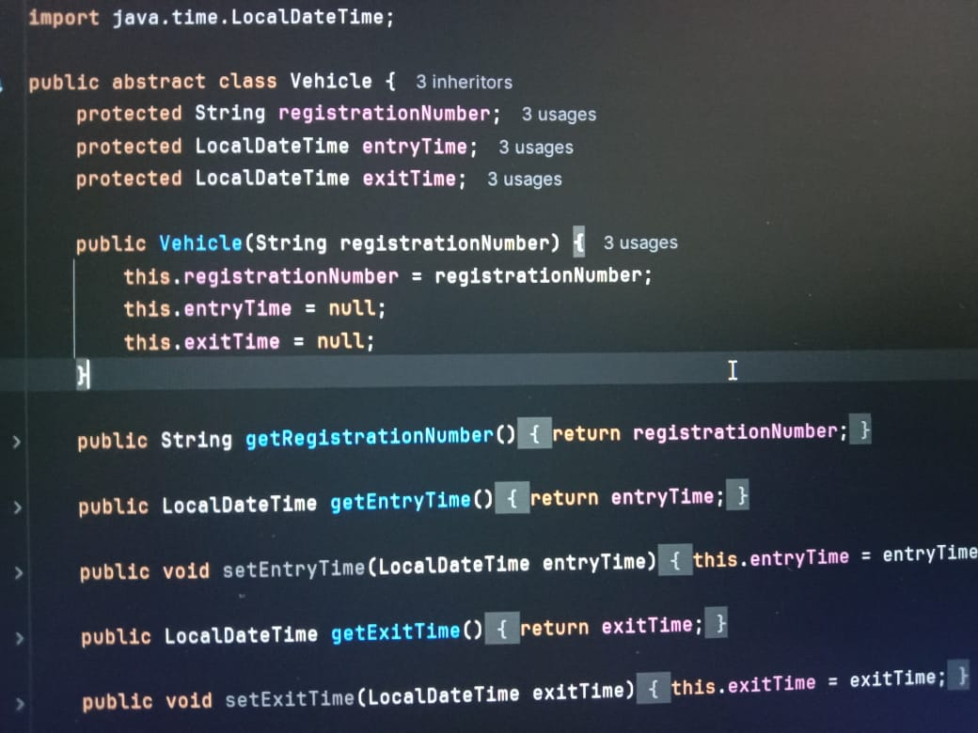

Key Methods:

* 1. Abstract method getVehicleDetails().
* 2. Methods to set and get entry/exit times.

### 3. UniversityBus Class

This class extends Vehicle and represents university buses. It includes additional details like driver and conductor names.

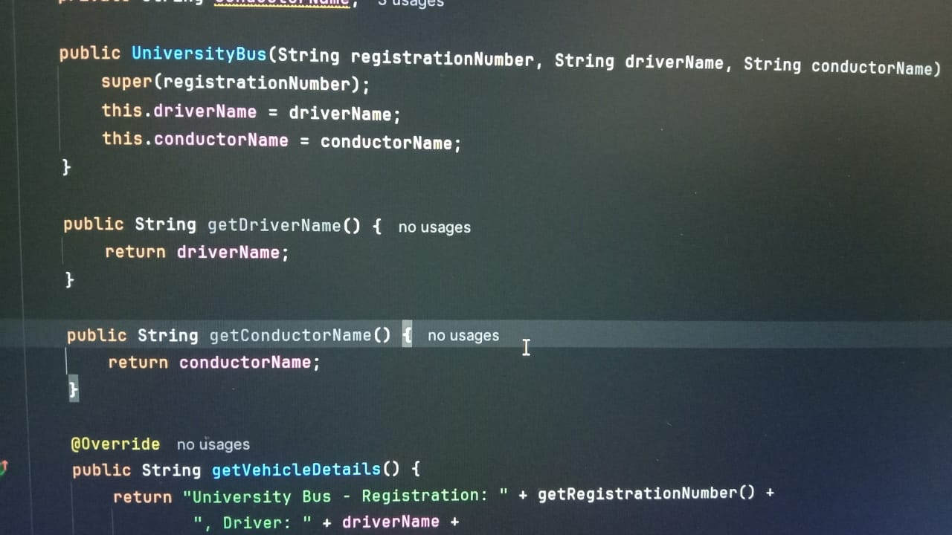

### 4. OtherVehicle Class

This class extends Vehicle and represents non-university vehicles. It includes details like vehicle type and driver CNIC.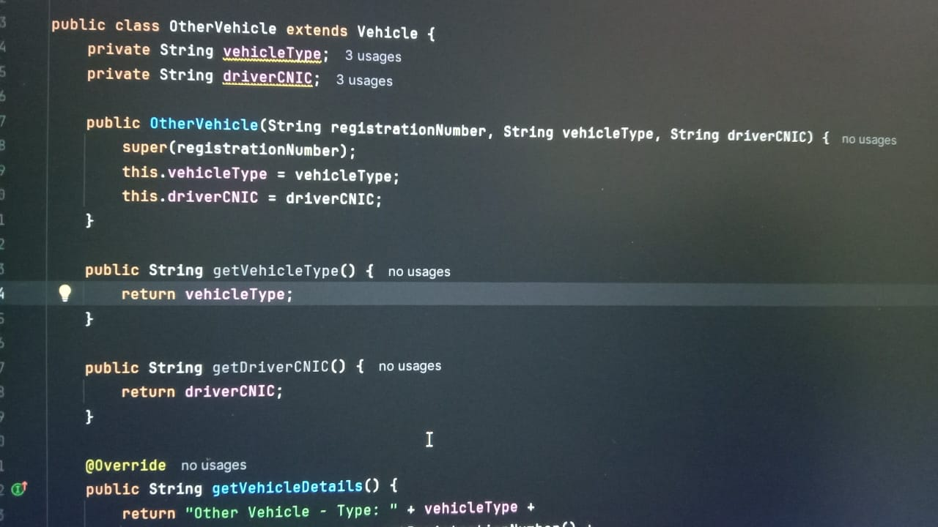

### 5. FacultyVehicle Class

This class extends Vehicle and represents faculty vehicles. It includes the faculty member's name.

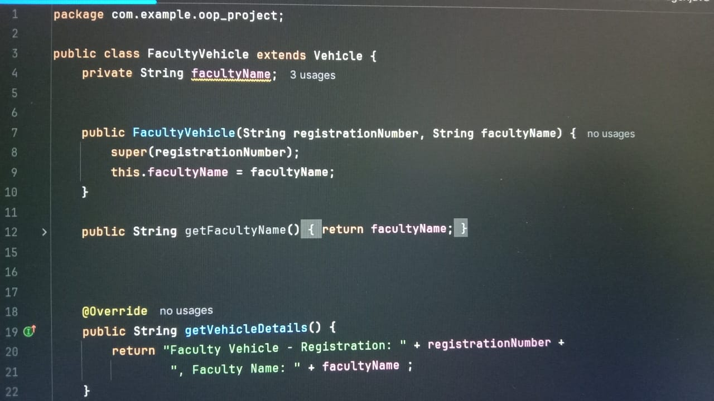

### 6. VehicleManager Class

This class manages vehicle logs. It logs entries and exits, generates reports, and provides methods for saving reports to files.

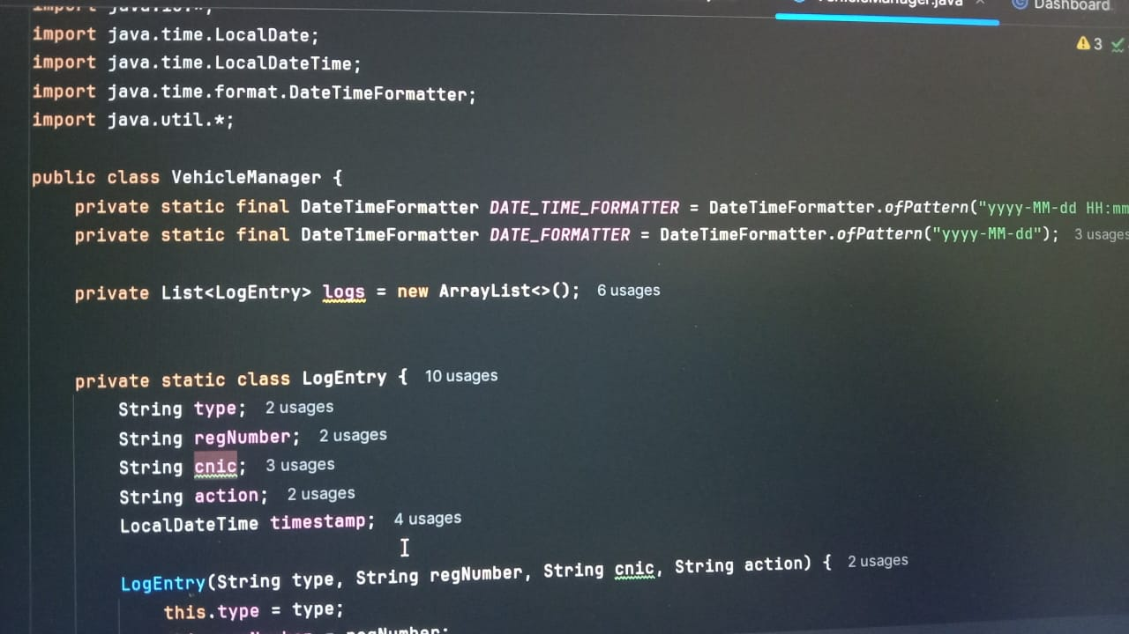

### 7. Dashboard Class

The Dashboard class provides the main user interface for logging vehicle entries and exits, viewing logs, and generating reports.

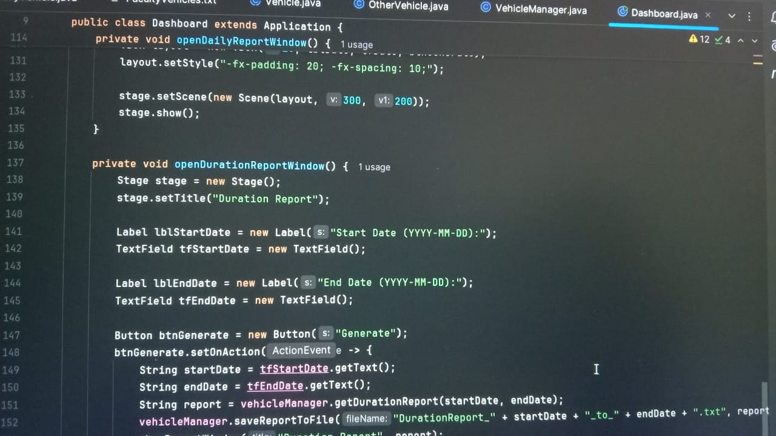

## Graphical User Interface (GUI)

The application uses JavaFX to provide an interactive GUI. The main features include:

* Login Page for user authentication.
* Dashboard with buttons for various functionalities.
* Separate windows for logging entries and exits.
* Text areas for displaying logs and reports.

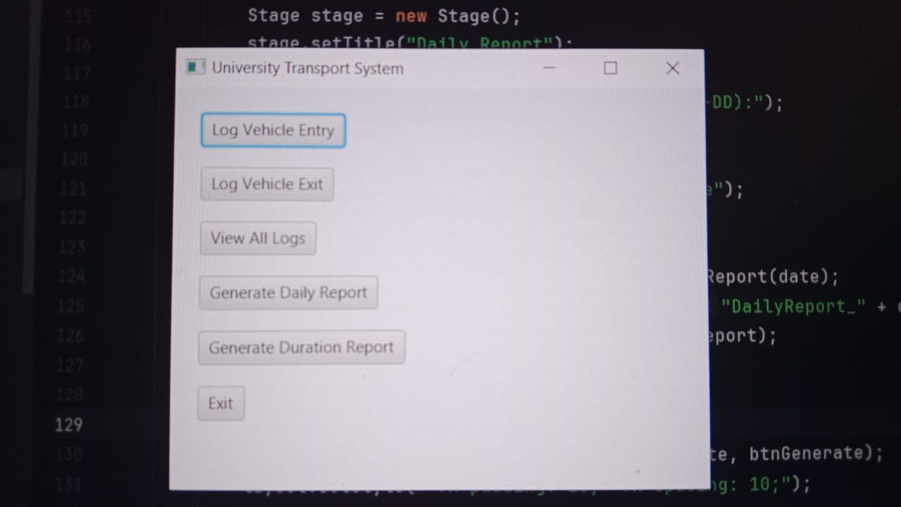

## File Handling

The application uses file handling for storing and retrieving user credentials and reports. The Users.txt file stores usernames and passwords, while generated reports are saved to text files for further reference.

## Summary

This University Transport System application effectively combines OOP concepts, JavaFX, and file handling to provide a robust solution for managing transport logs. The modular design ensures scalability and ease of maintenance.